City of Bastrop Permit Requirements

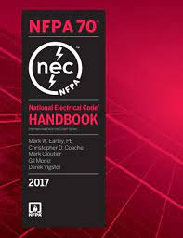

National Electric Code (NEC)

Annex H, 80.19 (C) Issuance of Permits
The authority having jurisdiction shall be authorized to establish and issue permits, certificates, notices and approvals or orders pertaining to electrical safety hazards pursuant to 80.23 Notice of Violations, Penalties, except that no permit shall be required to execute any of the classes of electrical work specified in the following:

No permit required:
- Installation or replacement of equipment such as lamps and of electric utilization equipment approved for connection to suitable permanently installed receptacles.
- Replacement of flush or snap switches, fuses, lamp sockets, and receptacles, and other minor maintenance and repair work, such as replacing worn cords and tightening connections on a wiring device.
- The process of manufacturing, testing, servicing, or repairing electrical equipment or apparatus.

Exemptions from IBC
- Repairs and maintenance: Minor repair work, including the replacement of lamps or the connection of approved portable electrical equipment to approved permanently installed receptacles.
- Radio and television transmitting stations: The provisions of this code shall not apply to electrical equipment used for radio and television transmissions but do apply to equipment and wiring for a power supply and the installations of towers and antennas.
- Temporary testing systems: A permit shall not be required for the installation of any temporary system required for the testing or servicing of electrical equipment or apparatus.

Exemptions from IRC
- Listed cord-and-plug connected temporary decorative lighting.
- Reinstallation of attachment plug receptacles but not the outlets therefor.
- Replacement of branch circuit overcurrent devices of the required capacity in the same location.
- Electrical wiring, devices, appliances, apparatus, or equipment operating at less than 25 volts and not capable of supplying more than 50 watts of energy.
- Minor repair work, including the replacement of lamps or the connection of approved portable electrical equipment to approved permanently installed receptacles.

